Annexure1

INVENTION DISCLOSURE FORM

- TITLE: AI-Powered Emotion-Based Music System – A Smart Adaptive Music Player Responding to User Emotions in Real-Time.

- INVENTOR(S)/ STUDENT(S):

A. Full name | Shashank Kumar
Mobile Number | 7607493996
Email | Shashankkm2003@gmail.com
UID/Registration number | 12305339
Address | Lovely Professional University, Punjab144411, India
Signature | 

A. Full name | Narendra Nath Sharma
Mobile Number | 9984385000
Email | narendra321132@gmail.com
UID/Registration number | 12314984
Address | Lovely Professional University, Punjab144411, India
Signature | 

A. Full name | Yash Chakraborty
Mobile Number | 7460944186
Email | yash.chakravarty186@gmail.com
UID/Registration number | 12300954
Address | Lovely Professional University, Punjab144411, India
Signature | 

External Inventor (if Any)
A. Full name
Mobile Number
Email
UID/Registration number
Address
Signature

- DESCRIPTION OF THE INVENTION

- PROBLEM ADDRESSED

Today, music significantly influences human emotions and productivity in the digital age. However, existing music systems cannot adjust to the emotional state of a person in real time. Often, people are forced to manually select songs that fit their mood. This process is neither efficient nor smooth.
A few existing platforms provide mood-based playlists, but they are based on hard-coded tags and not real-time emotional analysis. Those limitations can make them less agile in reacting to a person going through emotional shifts throughout the day.

- OBJECTIVE OF THE INVENTION

- The system is intended to establish an AI-based music system for identifying users' emotional conditions in real-time. It will be based on the analysis of facial expression, voice modulation and other biometric data (pulse, skin temperature, etc.).
- Consequently, the system will collect and play a playlist of the music that corresponds to the user's current emotional state (for example, for relaxing, boosting the mood or focusing).
- System uses Artificial Intelligence (AI), IoT sensors and deep learning algorithms to continuously analyze the user's emotions and adjust the playlist. It eliminates the need for manual selection, provides an immersive and personalized music experience.

- STATE OF THE ART/ RESEARCH GAP:

SN | Patent number | Title | Abstract | Difference
1. | US10286654B1 | Emotion Recognition System for Music Recommendation | A method of analyzing facial expressions and suggesting songs based on detected emotions. | The proposed system enhances this by integrating voice modulation analysis, biometric tracking, and real-time adaptive playlist management, ensuring a highly dynamic experience.
2. | US9876543B2 | AI-Powered Music Selection | Use predefined mood categories and user selection. | Our system works autonomously, continuously adapting based on real-time biometric and emotional inputs.
3. | JP5567893B2 | Adaptive Music Recommendation System | Suggests songs based on user mood history. | Unlike historical analysis, our system works dynamically in real-time, detecting immediate emotions and changing the playlist instantly if required.
4. | US5067890A | Voice-Based Mood Analysis | Uses voice tone to determine mood. | Our system combines multiple data points (facial, voice, and biometric) for higher accuracy and seamless automation.

DETAILED DESCRIPTION (Technical as well as non-Technical)

While the concept is not yet operational, this report outlines the system’s key components and functionalities, serving as a guide for future development.

      - Emotion Detection Module
This module is intended to monitor various physiological and behavioural indicators to determine the user's emotional state. It is likely to incorporate multiple AI-driven technologies:
- Facial Recognition: AI-powered cameras would scan facial expressions to detect emotions such as happiness, sadness, tension, and relaxation.
- Voice Recognition: Advanced voice analysis would assess tone, pitch, and speech patterns to determine the user's emotional state.
- Biometric Sensors: Future iterations may include sensors to track physiological metrics like heart rate, skin temperature, and pupil dilation.
- Real-Time Processing: The system would process data instantly to ensure accurate and responsive emotional recognition.

2. AI Music Recommendation Engine
Once the system detects the user’s emotional state, the AI music recommendation engine would select the most appropriate music. This module, when developed, would use deep learning models trained on extensive datasets to establish precise emotion-to-music mappings:
- Deep Learning-Based Music Selection: AI algorithms would analyse millions of songs and categorize them based on their emotional impact, tempo, lyrics, and instrumentation.
- Real-Time Adaptive Playlists: The system would create dynamic playlists that adjust according to the user's current emotional state, ensuring a seamless and engaging listening experience.
- Integration with Streaming Services: The platform would support integration with leading streaming services like Spotify, Apple Music, and YouTube, as well as local music libraries, allowing users to access personalized music recommendations from their preferred sources.

3. Smart Playback Control Module
To further enhance the listening experience, the system would include a smart playback control module that dynamically adjusts audio settings:
- Dynamic Tempo and Volume Adjustment: The system would modify the tempo and volume of a song in real-time to match the user’s mood.
- Mood-Based Music Transitions: The platform would smoothly transition between different music genres—shifting between relaxing, energetic, focus-enhancing, or motivational tracks as needed.
- Voice and Haptic Feedback: Users could customize their listening experience through voice commands or haptic feedback on smart devices, ensuring a more interactive experience.

4. Compatibility and User Experience
Though still in development, the AI-powered emotion-based music system is designed to be highly compatible across a range of devices:
- Smartphones and Tablets: Allowing users to access their personalized music playlists anytime, anywhere.
- Smart Home Assistants and Smart Speakers: Providing hands-free music playback and recommendations.
- Car Infotainment Systems: Enhancing driving experiences by dynamically adjusting music to match the driver’s mood.
- Wearable Devices: Smartwatches and fitness bands could offer continuous biometric feedback to refine real-time emotional analysis.

- ADVANTAGES OF THE INVENTION:

- Adaptive Real-Time Music Streaming – The system plays music dynamically without requiring user input for song selection. It automatically adjusts the playlist based on the user’s emotional state.
- Multi-Sensor Emotional Analytics – Utilizes facial recognition, voice tone analysis, and internal sensors to detect and analyse emotions in real time.
- Multichannel AI Customization – Employs deep learning models to curate personalized music sessions tailored to individual emotional and situational needs.
- Cross-Compatibility – Seamlessly integrates with popular music streaming platforms, including Spotify, Apple Music, and YouTube, ensuring a smooth listening experience.
- Enhanced Productivity and Well-Being – Offers specialized music for different activities, such as high-energy beats for workouts and focus-enhancing tracks for concentration.
- Mood-Adaptive Playback – Dynamically adjusts song order, playback speed, and volume based on the user’s emotional state, ensuring a fluid and immersive listening experience.
- AI In-Sensing Feature – The system detects user presence and emotions even without direct interaction, offering a hands-free experience.
- Independent Operation or IoT Integration – Can function as a standalone device or integrate with smart home ecosystems, working alongside other IoT devices.
- Standby Energy Saver Mode – Automatically enters low-power mode when idle to conserve energy.
- Cloud-Ready or Standalone Operation – Can function independently or be integrated into cloud-based IoT systems for a more connected experience.
- Emergency Response System – In extreme distress situations, the system can send automated alerts to emergency contacts or activate a robotic calming feature to provide comfort.

- EXPANSION
- enveloping AI models for emotion detection and music recommendations.
- Integrating biometric sensors for real-time emotional feedback.
- Creating APIs for seamless connectivity with leading music streaming platforms.
- Testing and refining the system in diverse real-world scenarios.

- WORKING PROTOTYPE / FORMULATION / DESIGN / COMPOSITION

To demonstrate the functional architecture and processes of the AI-Powered Emotion-Based Music System, the following flowcharts illustrate key components, workflows, and the predictive analytics process that drive the system.

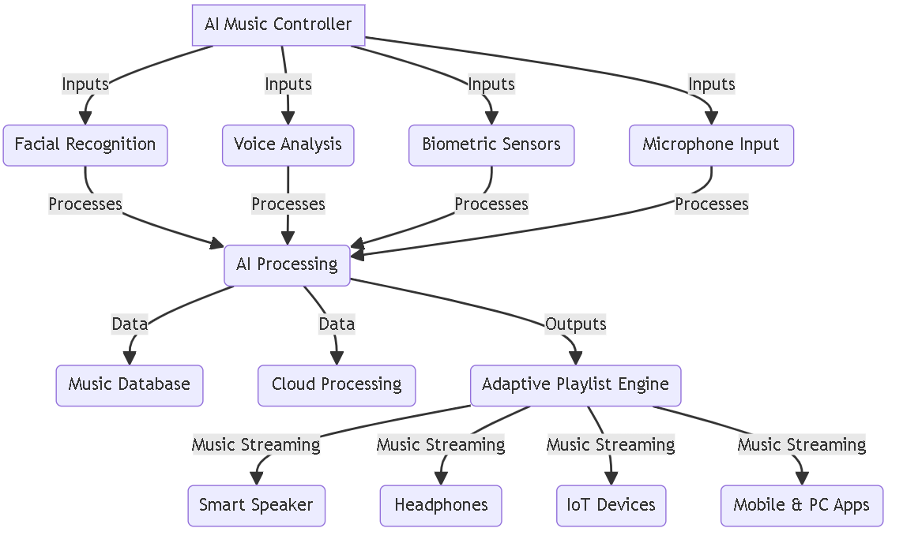

Figure 3. The Component architecture for the AI-Powered Emotion-Based Music System

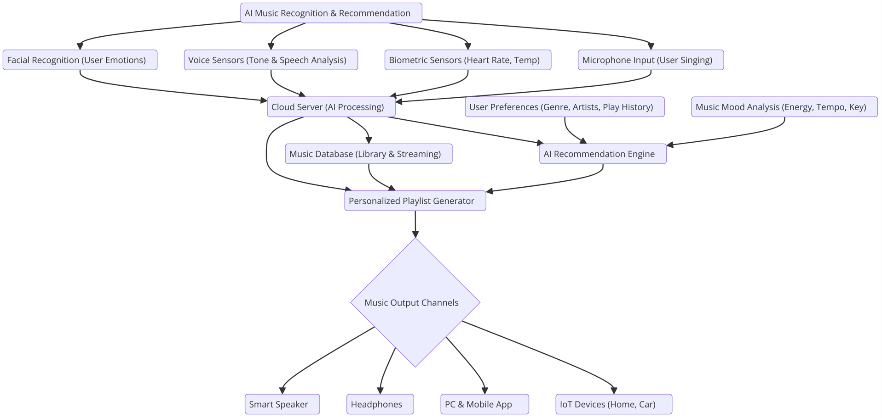

Figure 2. The imaginary working architecture for AI-Powered Emotion-Based Music System

- EXISTING DATA:
Existing music platforms rely on past data and manual playlists, lacking real-time emotion-based adjustments. The proposed system uses AI-driven emotion recognition with biometric integration for adaptive, personalized playback across IoT-enabled devices.

- USE AND DISCLOSURE

Question | YES | No
A. Have you described or shown your invention/design to anyone or in any conference? |  | ✔️
B. Have you made any attempts to commercialize your invention (e.g., approached companies)? |  | ✔️
C. Has your invention been described in any printed publication or other media (e.g., Internet)? |  | ✔️
D. Do you have any collaboration with any other institute or organization on the same? |  | ✔️
E. Is there any regulatory body or other approvals required? |  | ✔️

5. PUBLIC DISCLOSURE:
6. MOU TERMS (if any):
7. POTENTIAL CHANCES OF COMMERCIALIZATION
- Licensing to music streaming platforms like Spotify and Apple Music.
- Integration with smart speakers and IoT devices.
- Partnerships with wearable tech companies.
- Implementation in automotive infotainment systems.
- Collaboration with mental health and wellness applications.
- Monetization through subscription models and API licensing.
- Use in gaming and VR entertainment platforms.
- Adoption in corporate wellness programs.
8. COMPANIES FOR COMMERCIALIZATION:
9. ROYALTY OBLIGATIONS:
10. FILING OPTIONS:
(YES)Provisional / Complete / PCT Filing

KEYWORDS: AI, IoT, Cloud Computing, Emotion Recognition, Music System, Smart Speaker, Deep Learning, Biometric Analysis, Facial Recognition, Voice Analysis, Adaptive Playlist, Real-Time AI Music, Music Recommendation Engine, Mood-Based Playback, Automated Music Personalization, Wearable AI Technology, Cross-Platform Music Compatibility, Cloud-Enabled Music System, Haptic and Voice Feedback, AI-Powered Music Player, Emotional AI Analysis, Neural Network-Based Music Selection, Autonomous Music Curation, Smart Music Streaming, IoT Integration.

(Letter Head of the external organization)

NO OBJECTION CERTIFICATE

This is to certify that University/Organization Name or its associates shall have no objection if Lovely Professional University files an IPR (Patent/Copyright/Design/any other…….) entitled "…………………." including the name(s) of, ........... …as inventors who is(are) student(s)/employee(s) studying/ working in our University/ organization.
Further Name of the University/Organization shall not provide any financial assistance in respect of said IPR nor shall raise any objection later with respect to filing or commercialization of the said IPR or otherwise claim any right to the patent/invention at any stage.

(Authorized Signatory)

